# *Part I – Agency Profile*

**Agency Overview**

***Mission, Vision, Purpose***

The Idaho Department of Correction’s mission is to “Create a model correctional system that provides equitable access to programming and opportunities that reflect a community experience, foster connection, and restore victims of crime.” The Department envisions a safer Idaho with fewer people in its correctional system. We value:

1. integrity in all our interactions; 2) respect for diversity and humanity in each other and those under our jurisdiction; and 3) positive attitude that recognizes everyone’s ability to change. The agency mission and values encourage ethical, safe, and evidence-based practices while providing care and custody for adult felons, pre- sentence investigation reports for the courts, and supervision of probationers and parolees.

***Governance and Structure***

A three-member Governor-appointed board provides oversight to the agency. Dr. David McClusky was appointed in January 2013 and serves as Chairman. Dodds Hayden was appointed in January 2019 and serves as Vice- Chairman. The position of Secretary is currently vacant. The Board is appointed to six- year terms. The Idaho Board of Correction appointed Josh Tewalt as Director in December 2018.

The Idaho Department of Correction employs 2,177 full and part time professionals and is organized into three divisions: 1) prisons; 2) probation and parole; and 3) management services.

* + The Prisons Division manages residents in ten state correctional institutions, providing institutional safety services and management of special projects. The division is also responsible for resident placement, education, and treatment services. The Probation and Parole Division supervises probationers and parolees living within seven Idaho districts, managing 25 probation and parole offices and Interstate Compact. The division also manages five community reentry centers, community-based substance abuse treatment, and provides pre-sentence investigation reports to the courts.
  + The Management Services Division has oversight over capital construction, grant administration, contract services and monitoring, central records, purchasing, and health care services for prison facilities and county jails. In addition, Management Services provides oversight over contracted prison facilities in and out of state.

In addition to the above core divisions, the Director’s Office manages the functions of Human Resources, Victims’ Services, Communications, Evaluation & Compliance and Strategic Initiatives. The director and deputy directors also provide oversight to Special Investigations, and Idaho Correctional Industries (a self-funded incarcerated resident training program established as a separate agency).

Revenue for the Idaho Department of Correction comes from the general fund, cost of supervision fees, work crew revenue, miscellaneous revenue (Inmate Management Fund), penitentiary (endowment), Millennium and liquor funds, and federal grants.

**Core Functions/Idaho Code**

Incarceration Services: Provide for the care and custody of felony residents committed to the custody of the state Board of Correction. (Title 20, Chapter 1)

Probation and Parole Supervision: Supervise all persons convicted of a felony and placed on probation or released from prison and placed on parole. (Title 20, Chapter 2)

Programs and Education: Provide rehabilitation to reduce risk to re-offend. (Title 20, Chapter 1)

Pre-sentence Reports: Investigate backgrounds and create reports to help the courts with sentencing decisions. (Title 20, Chapter 2)

**Revenue and Expenditures**

|  |  |  |  |  |
| --- | --- | --- | --- | --- |
| **Revenue** | **FY 2022** | **FY 2023** | **FY 2024** | **FY 2025** |
| General Fund | $281,049,100 | $303,606,400.00 | $316,792,800 |  |
| Work Crews | $8,404,500 | $11,048,200.00 | $15,789,100 |  |
| Parolee Supervision Fund | $6,885,400 | $7,423,500.00 | $9,324,600 |  |
| Federal Grant | $1,506,100 | $1,731,000.00 | $2,979,600 |  |
| Miscellaneous Revenue | $4,275,100 | $3,822,300.00 | $5,093,400 |  |
| ARRA/CARES | $0 | $0 | $0 |  |
| Liquor Fund | $513,700 | $531,200.00 | $654,000 |  |
| Hepatitis C | $2,326,100 | $5,741,900.00 | $3,932,000 |  |
| Millennium Fund | $0 | $0 | $0 |  |
| Technology Infrastructure | $0 | $0 | $1,200,000 |  |
| Penitentiary | $2,376,800 | $3,082,400.00 | $3,257,600 |  |
| American Rescue Plan Act | $0 | $10,500,000.00 | $500,000 |  |
| **Total** | **$307,336,800** | **$347,486,900.00** | **$359,523,100** |  |
| **Expenditures** | **FY 2022** | **FY 2023** | **FY 2024** | **FY 2025** |
| Personnel Costs | $137,254,900 | $157,970,800.00 | $194,331,600 |  |
| Operating Expenditures | $151,024,600 | $172,643,000.00 | $157,377,900 |  |
| Capital Outlay | $16,580,500 | $13,831,200.00 | $4,567,100 |  |
| Trustee/Benefit Payments | $2,476,800 | $3,041,900.00 | $3,246,500 |  |
| **Total** | **$307,336,800** | **$347,486,900.00** | **$359,523,100** |  |

**Profile of Cases Managed and/or Key Services Provided**

|  |  |  |  |  |
| --- | --- | --- | --- | --- |
| **Cases Managed and/or Key Services Provided** | **FY 2022** | **FY 2023** | **FY 2024** | **FY 2025** |
| Incarcerated Offenders *(Year-end)* | 9,060 | 9,399 | 9,657 |  |
| Community Supervised, In State *(Year-end1)* | 16,066 | 15,765 | 15,878 |  |
| Interstate Compact Supervised Offenders2 | 2,629 | 2,785 | 2,798 |  |
| Pre-sentence Investigation Reports | 5,281 | 6,983 | 5,703 |  |
| Term Prison Admissions | 3,231 | 3,690 | 2,981 |  |
| Retained Jurisdiction Prison Admissions | 2,165 | 2,478 | 2,109 |  |
| Parole Violator Prison Admissions | 1,735 | 1,548 | 1197 |  |
| Total Prison Admissions | 7,131 | 7,217 | 6,287 |  |
| GED/HSE Completions | 163 | 204 | 226 |  |
| IDOC Prison Bed Cost Per Day3 | $83.996 | $84.80 | $92.86 |  |
| Supervision Cost Per Day4 | $5.28 | $6.65 | $7.12 |  |
| Correctional Officer Turnover Rate | 26.6% | 19.8% | 21.9% |  |
| IDOC Staff Turnover Rate, All Non-CO Staff | 11.4% | 7.80% | 8.20% |  |
| Supervised Offender to Officer Ratio5 | 70 to 1 | 69 to 1 | 69 to 1 |  |

**Profile of Cases Managed and/or Key Service Provided Explanatory Notes**

1. The fiscal year end totals include probationers and parolees supervised in Idaho’s seven districts, including those managed in the Limited Supervision Unit. It does not include individuals under IDOC’s jurisdiction living in other states through Interstate Compact.
2. Interstate Compact fiscal year end community supervised are Idaho sentenced probationers and parolees who are currently living in other states.
3. Bed costs reflect the average cost of all beds used by the Department, including all prison facility beds, community reentry centers, and contract beds.
4. The agency calculates the supervision cost per day based on all supervised individuals in state and those managed on Interstate Compact in other states. Approximately 20% of the budget is funded through cost of supervision fees.
5. The supervised client to officer ratio reflects the average caseload size in Idaho. Specialized caseloads such as sex offender and problem-solving court caseloads are much lower than the average, resulting in general caseloads with over 100 individuals. The rate is based on the year-end total population on the year-end total population compared to number of Probation and Parole Officer PCNs, not including vacancies (15,765/228).
6. Cost per day for FY22 has been revised from last year’s report to reflect a more accurate cost.

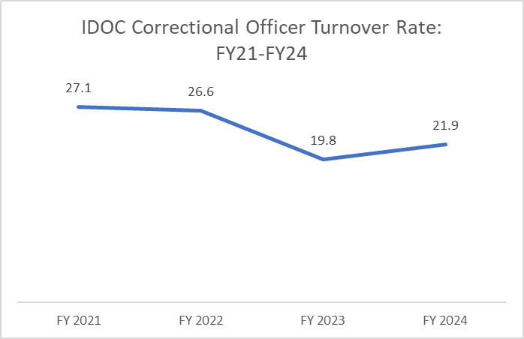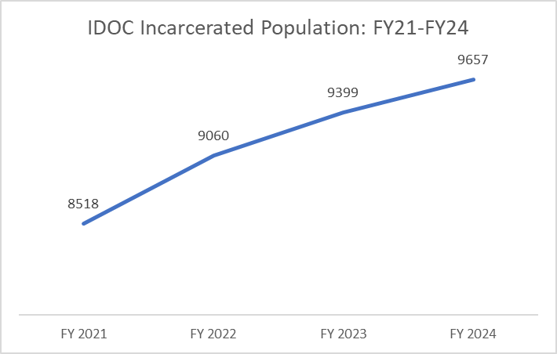

***Part II – Performance Measures***

| **Performance Measure** | | **FY 2022** | **FY 2023** | **FY 2024** | **FY 2025** | **FY 2026** |
| --- | --- | --- | --- | --- | --- | --- |
| **Goal 1. Create safer communities by increasing success for those under IDOC jurisdiction.** | | | | | | |
| 1. Increase the percentage of probationers, parolees, and full-term releases from prison who are successful at three years by 2.5% each year. | actual | 64% | 61% | 63% |  |  |
| *target* | *67.5%* | *70.0%* | *72.5%* | *75%* |  |
| 2. Increase program offerings to address root causes of incarceration including trauma, disconnection from family and community, and deficits in education and life skills. | actual | 1,903  programs | 1,030 programs | 1,115 programs |  |  |
| *target* | *>1,903* | *>1,903* | *>1,903* | *>1,903* |  |
| 3. Decrease in assaults, use of force incidents, and suicides amongst those in custody. | actual | 818 | 867 | 837 |  |  |
| *target* | *<835* | *<835* | *<835* | *<835* |  |
| **Goal 2: Enhance staff fulfillment and wellness** | | | | | | |
| 4. Maintain high staff retention rate- increase by 2% annually. | actual | 83.4% | 87.9% | 86.3% |  |  |
| *target* | *89%* | *90%* | *92%* | *94%* |  |
| 5. Increase length of service with IDOC for correctional officers. | actual | 5.6 yrs | 4.1 yrs | 3.22 yrs |  |  |
| *target* | *>5.6* | *>5.6* | *>5.6* | *>5.6* |  |
| 6. Invest in professional development opportunities. | actual | 15% | 15% | 17% |  |  |
| *target* | *15%* | *15%* | *15%* | *15%* |  |
| **Goal 3: Focus spending on areas that maximize success** | | | | | | |
| 7. Increase investment in community corrections where IDOC can maximize crime reduction efforts – an additional 1% of the total IDOC budget to community corrections each year. | actual | 0.7% | 0.5% | -0.4% |  |  |
| *target* | *Reallocate 1.0%* | *Reallocate 1.0%* | *Reallocate 1.0%* | *Reallocate 1.0%* |  |
| 8. Reduction in county jail length of stay for state- sentenced individuals awaiting admission to IDOC facilities by 2% each year. | actual | 34 days | 49 days | 43 days |  |  |
| *target* | *56.8 days* | *55.7 days* | *54.6 days* | *53.5 days* |  |
| **Goal 4: Strengthen relationships with key stakeholders.** | | | | | | |
| 9. Reduce the number of public records requests coming to IDOC as a result of information being more readily available to the public by 5% each year. | actual | 1,341 | 6,010 | 6,497 |  |  |
| *target* | *Target in development* | *1,274* | *<5,710* | *<5,710* |  |

**Performance Measure Explanatory Notes**

**Measure 1: Percentage of probationers, parolees, and full-term releases from prison who are successful at three years.**

In FY20, this performance measure was added, and the goal was set to increase the percentage that are successful at three years by 2.5% each year. In FY21 and FY22 IDOC stayed at 64%. In FY2023 the percentage dropped to 61%, but it has rebounded in FY24 back up to 63%. IDOC remains below the target success rate.

*Impact*: IDOC continues to monitor the success of everyone on supervision and after release from custody to help establish whether interventions have had the intended effect. Improvements in success rates translate to more people living productively and crime-free in the community and saving taxpayer dollars that would otherwise be spent on incarceration or supervision. There are a variety of reasons for why the three-year success rate has remained low, including both community and societal factors that may not be within the control of IDOC, such as employment opportunities, access to mental health treatment, housing, and transportation.

**Measure 2: Increase program offerings to address root causes of incarceration including trauma, disconnection from family and community, and deficits in education and life skills.**

This performance measure was added in FY21, and the benchmark set at the number of programs offered in FY22. During FY24, there were 1,115 different programs offered to incarcerated individuals, an increase over the prior fiscal year. However, there have been changes in which programs are captured and counted within IDOC’s new case management system, Atlas, making a direct comparison to previous years’ data impossible.

*Impact:* IDOC offers courses spanning a vast array of topics, primarily centered on personal learning, growth, and development. The core programming includes cognitive based interventions on substance use, aggression reduction therapy, criminal thinking, and sex offending. Other offerings included GED preparation, entrepreneurship, personal finance, parenting, life skills, and pre-release programming. Although the number of documented programs offered in FY23 is lower than the previous year, this does not reflect the true count of all classes. IDOC transitioned to the new system, Atlas, on 11/11/22. Although staff have been trained to enter data, they have been focused primarily on documenting information about the main core curriculum and not on the extra programs that are offered.

**Measure 3: Decrease in assaults, use of force incidents, and suicides among those in custody.**

During the past fiscal year, there was a combined total of 837 assaults, use of force incidents, and suicides amongst those in custody. There was a decrease in incidents in FY2024 compared to the prior fiscal year, and IDOC is now essentially at the initial target set for these incidents. The decline in incidents was driven by a decrease in assaults from 479 to 448.

*Impact:* Running safe prisons is requisite for any rehabilitative efforts to be effective*.* IDOC will continue to monitor to determine whether strategies adopted in prisons to improve culture and create more normative environments are translating into fewer incidents of violence and resident suicide.

**Measure 4: Maintain high staff retention rate (changed to increase by 2% per year).**

The staff retention rate is based on the number of voluntary staff separations compared to filled positions for each fiscal year. Separations only include those that are voluntary and do not include those for military service, retirement, or lay-offs. The filled position total is calculated by taking the agency population at two snapshots in time at mid and end year and averaging them together. Total separations for the year are then divided by the average full-time filled positions to obtain the rate. For FY24, the rate was 86.3%, a decrease compared to the prior fiscal year but higher than FY21 or FY22.

*Impact:* Measuring staff retention will help determine whether new programs aimed at supporting the job satisfaction of staff, such as the PURPOSE in Action initiative and increasing compensations has had a positive effect. The measure helps establish whether worker morale has increased at central office, at correctional facilities, and in the districts.

**Measure 5: Increase length of service with IDOC.**

This measure was added in FY21 to monitor the overall length of service employees have worked for IDOC. The average amount of time employees had worked for IDOC at the end of FY22 was 5.6 years, and this became the benchmark. Staffing levels dropped during and after the Covid pandemic, as IDOC had to fill an unusually high number of correctional officer vacancies. Facilities are now more fully staffed than they have been in recent years, which means there are many new staff who are bringing down the staff average length of service.

*Impact:*  Monitoring the amount of time employees have worked for IDOC helps guide recruitment and retention efforts.

**Measure 6: Invest in professional development opportunities for minimum of 15% of staff annually.**

Over the course of the year, IDOC was able to provide leadership training opportunities to more than 15% of all full-time staff working for the agency within the fiscal year.

*Impact:* Investment in leadership training helps to ensure that leadership are engaged with the vision, mission and goals of the agency and will provide excellent relational management skills and strive to retain employees. Approximately 381 staff were trained in leadership classes last fiscal year, and dozens more attended national conferences to learn best practices from around the country.

**Measure 7: Increase investment in community corrections where IDOC can maximize crime reduction efforts – an additional 1% of the total IDOC budget to community corrections each year.**

The FY24 benchmark was to increase the investment in Community Corrections by 1.0%. While the percentage of the overall budget dedicated to community corrections decreased slightly this year, by 0.4%, IDOC invested over $5.7 million dollars more in community corrections than in FY2023. IDOC invested over $60 million dollars in community corrections, a greater than 10% increase over the prior fiscal year.

|  |  |  |  |  |  |  |
| --- | --- | --- | --- | --- | --- | --- |
| IDOC BASE BUDGET - EXCLUDES ONE-TIME AMOUNTS | | | | | | |
|  | FY24 | | FY25 | | Change | |
|  | Total | % Total |  |  | Total | % Total |
| Support Services | $21,561,600.00 | 5.87% |  |  |  |  |
| Prisons | $284,978,400.00 | 77.59% |  |  |  |  |
| Community Corrections | $60,756,600.00 | 16.54% |  |  |  |  |
| Total | $367,296,600.00 | 100.00% |  |  |  |  |

*Impact:* Monitoring the portion of IDOC’s budget spent on the community rather than prisons establishes the goal for IDOC that we will strive to provide more resources to those on supervision, where we can have greater impacts on reducing crime. The research is clear that community interventions generate the biggest reductions in recidivism, outweighing even the best prison-based interventions.

**Measure 8: Reduction in county jail length of stay for state-sentenced individuals awaiting admission to IDOC facilities.**

Housing in county jails adds significantly to the IDOC budget. Worse still, during jail time, incarcerated individuals cannot participate in IDOC programs that help reduce risk. To improve efficiency, it is important to move people into state facilities where the rehabilitation process can begin in earnest. Investments in technology, transportation and movement will decrease county jail length of stay by more swiftly bringing people into state custody and assigning them to facilities that offer the requisite programming for release. In FY24, the average length of stay in county jails prior to incarceration within IDOC decreased to 43 days, which is below the established goal of 54.6 days. Converting data systems mid-FY23 caused new challenges in this workflow that appear to be abating, as the average for FY24 was lower than FY23.

*Impact:* IDOC monitors how long individuals are housed in county jails, prior to prison admission, as a measure of how effectively we are allocating resources and ensuring that justice-involved individuals have access to rehabilitative programming.

**Measure 9: Reduce the number of public records requests coming to IDOC as a result of information being more readily available to the public.**

This measure was first recorded in FY22, and a target was set to reduce the number of requests to 1,274. However, a change in process occurred and all public records requests now go through one central location. With this improved counting, a new target was set to decrease public records requests to 5,710. IDOC received 6,497 public records requests in FY24, an increase over the prior fiscal year. Demand for information remains high, and IDOC has developed a transparency team to share as much as possible with the public while protecting data privacy.

*Impact:* By monitoring the number of requests received, IDOC is placing emphasis on providing more information in a more readily available fashion, offering transparency and accountability to the general public.

|  |
| --- |
| **For More Information Contact**  Jeffrey Lojewski  Correction, Department of  1299 N Orchard Suite 110  PO Box 83720  Boise, ID 83720-0018  Phone: (208) 605-4777  E-mail: [jlojewsk@idoc.idaho.gov](mailto:jlojewsk@idoc.idaho.gov) |